AMAZON SALES ANALYSIS USING SQL AND POWER BI

Prepared By : Vanshika Singh

Date : May 2026

Table of Contents

- Introduction
- Project Objectives
- Dataset Description
- Tools and Technologies
- Data Cleaning
- SQL Analysis
- Dashboard and Visualizations
- Key Insights
- Recommendations
- Conclusion

INTRODUCTION

In today's digital era, e-commerce has become one of the fastest-growing industries worldwide. Online marketplaces generate a large amount of sales data that can be analyzed to understand customer behavior, product performance, and business trends.
This project, "Amazon Sales Analysis Using SQL," focuses on analyzing Amazon sales data to gain meaningful business insights. The dataset contains information such as order details, product categories, sales amount, order status, fulfillment methods, and shipping locations.
The main objective of this project is to use SQL for data cleaning, data exploration, and sales analysis. Various queries are performed to identify sales trends, top-performing products, high-demand cities, order statuses, and overall business performance.
The findings from this analysis can help businesses make data-driven decisions, improve customer satisfaction, optimize inventory management, and increase revenue. This project also demonstrates the practical application of SQL in solving real-world business problems and extracting valuable insights from large datasets.

PROJECT OBJECTIVES

The primary objective of this project is to analyze Amazon sales data using SQL and derive meaningful business insights from the dataset. The specific objectives of the project are:
- To import and clean the Amazon sales dataset for accurate analysis.
- To explore the dataset and understand its structure, columns, and data quality.
- To calculate total sales, total orders, and overall business performance.
- To identify the top-selling product categories and products based on sales and quantity.
- To analyze order statuses such as shipped, delivered, returned, and cancelled orders.
- To determine the cities and regions generating the highest number of orders.
- To evaluate the performance of different fulfillment methods.
- To identify sales trends and patterns that can support business decision-making.
- To generate actionable insights and recommendations for improving sales performance and customer satisfaction.
- To demonstrate the practical application of SQL in data cleaning, querying, and business analytics.

DATASET DESCRIPTION

The dataset used in this project is an Amazon Sales Dataset containing information about customer orders, product categories, sales revenue, order status, product sizes, and shipping locations. The dataset was analyzed using SQL and visualized through a Power BI dashboard to identify sales trends and business insights.
Dataset Features
The dataset includes the following important fields:
Column Name | Description
Order ID | Unique identifier for each order
Date | Date on which the order was placed
Category | Product category (Set, Kurta, Saree, etc.)
Size | Product size (M, L, XL, XXL, etc.)
Qty | Quantity of products ordered
Amount | Revenue generated from the order
Status | Order status (Shipped, Delivered, Cancelled, etc.)
Ship-City | Customer's shipping city
Ship-State | Customer's shipping state
Fulfilment | Order fulfillment method
Dataset Summary
- Total Orders: 128,975
- Total Revenue: ₹78.59 Million
- Number of Cities: 7,298
- Multiple Product Categories analyzed
- Order statuses include Shipped, Delivered, Returned, and Cancelled
Purpose of the Dataset
The dataset was used to:
- Analyze sales performance.
- Identify top-performing product categories.
- Study customer purchasing behavior.
- Examine order status distribution.
- Determine top-performing cities.
- Generate business recommendations for improving sales and operational efficiency.

TOOLS AND TECHNOLOGIES

Tools Purpose
PostgreSQL Data Analysis
SQL Querying
Power BI Dashboard
Excel Data Review

DATA CLEANING

- Checked Null Values.

- Checked duplicates.

- Verified data types.

- Validated Amount column.

- Verified Order Status column.

- Verified Order Status Values.

SQL ANALYSIS

Analysis 1 : Order Status Analysis

SQL Query
SELECT status, COUNT(*) AS total_orders
FROM "amazon_sales"
GROUP BY status
ORDER BY total_orders DESC;

Result:

Status | Total_Order
Shipped | 77804
"Shipped - Delivered to Buyer | 28769
Cancelled | 18332
Shipped-Returned to Seller | 1953
Shipped-Picked Up | 973
Pending | 658
Pending-Waiting for Picked | 281
Shipped-Returning to Seller | 145
Shipped-Out for Delivery | 35
Shipped- Rejected by Buyer | 11
Shipping | 8
Shipped- Lost in Transit | 5
Shipped- Damaged | 1

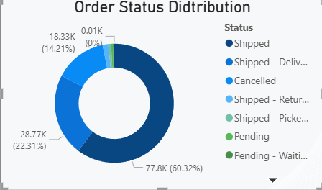

Insight :
- Most orders are in Shipped status, showing active order fulfillment.
- 18,332 orders were cancelled, which is a significant number and needs investigation.
- 1,953 orders were returned to the seller, indicating possible issues with product quality, size, expectations, or delivery.
- Very few orders were lost in transit (5) or damaged (1), indicating good logistics performance.
Some orders are still in pending and pickup stages, suggesting processing delays

Analysis 2: Category- wise Sales Analysis
SQL Query
Select category,
SUM(amount) AS total_sales
FROM "amazon_sales"
GROUP BY category
ORDER BY total_sales DESC;

Results :

Category | Revenue
Set | ₹39,204,124.03
Kurta | ₹21,299,546.70
Western Dress | ₹11,216,072.69
Top | ₹5,347,792.30
Ethnic Dress | ₹791,217.66
Blouse | ₹458,408.18
Bottom | ₹150,667.98
Saree | ₹123,933.76
Dupatta | ₹915.00

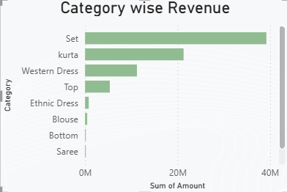

Insight :
- Set is the highest revenue-generating category with more than ₹39.2 million in sales.
- Kurta is the second-best performer, generating over ₹21.2 million.
- Western Dress contributes significantly with over ₹11.2 million revenue.
- The top three categories (Set, Kurta, Western Dress) account for the vast majority of total revenue.
- Categories such as Dupatta, Saree, Bottom, and Blouse contribute very little revenue.
- Customer demand appears to be concentrated in ethnic wear and coordinated apparel sets.

Analysis 3: Category- wise Order Volume
SQL Query
SELECT category,
COUNT(*) AS total_orders
FROM "amazon_sales"
GROUP BY category
ORDER BY total_orders DESC;

Results :

Category | Quantity Sold
Set | 50,284
Kurta | 49,877
Western Dress | 15,500
Top | 10,622
Ethnic Dress | 1,159
Blouse | 926
Bottom | 440
Saree | 164
Dupatta | 3

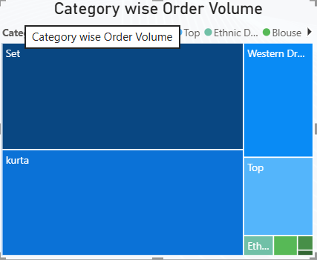

Insight :
- Set is the most sold category with 50,284 units sold.
- Kurta follows very closely with 49,877 units sold.
- Western Dress and Top have moderate sales volumes compared to the top two categories.
- The majority of sales volume comes from Set and Kurta, indicating strong customer preference for these products.
- Dupatta, Saree, and Bottom have very low sales volumes, suggesting limited customer demand.
- The quantity sold pattern closely matches the revenue analysis, confirming that the highest revenue categories are also the most popular by volume.
Analysis 4: Size- wise Order Analysis
SQL Query
SELECT size,
COUNT(*) AS total_orders
FROM "amazon_sales"
GROUP BY size
ORDER BY total_orders DESC;

Results :

Size | Quantity Sold
M | 22,711
L | 22,132
XL | 20,876
XXL | 18,096
S | 17,090
3XL | 14,816
XS | 11,161
6XL | 738
5XL | 550
4XL | 427
Free | 378

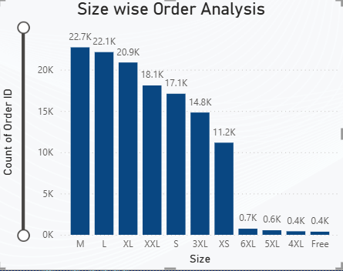

Insight :
- Medium (M) is the most popular size with 22,711 units sold.
- Large (L) and XL are also highly demanded sizes.
- Most sales come from the size range S to XXL.
- There is significant demand for 3XL, indicating a market for plus-size clothing.
- Sizes 4XL, 5XL, and 6XL have relatively low sales but still contribute to overall demand.
- Customer demand is concentrated in standard sizes, which should be prioritized in inventory planning.

Analysis 5: City- wise Order Analysis
SQL Query
SELECT ship_city,
COUNT(*) AS total_orders
FROM "amazon_sales"
GROUP BY ship_city
ORDER BY total_orders DESC;

Results :

City | Orders
BENGALURU | 11,217
HYDERABAD | 8,074
MUMBAI | 6,126
NEW DELHI | 5,795
CHENNAI | 5,421
PUNE | 3,857
KOLKATA | 2,381
GURUGRAM | 1,868
THANE | 1,701
LUCKNOW | 1,458

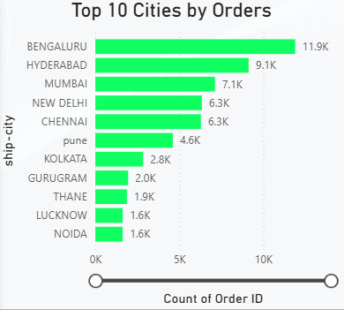

Insight :
- Bengaluru has the highest number of orders, making it the strongest market.
- Hyderabad, Mumbai, New Delhi, and Chennai are also major contributors to sales volume.
- Most orders come from large metropolitan cities.
- Tier-1 cities dominate customer demand.
- Lucknow appears in the Top 10, showing good demand from non-metro cities as well.
- The data contains duplicate city names due to inconsistent capitalization (e.g., BENGALURU, Bengaluru, Bangalore, bangalore), which should be cleaned during data preparation.

Data and Visualizations

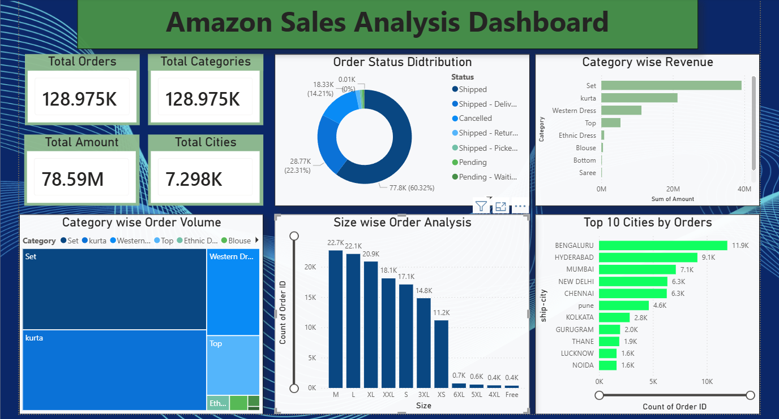

Power bi Dashboard

Key Insights:
1. Strong Overall Sales Performance
- Total Orders: 128.97K
- Total Revenue: ₹78.59 Million
- Orders were received from 7,298 cities, showing a wide customer reach.
2. Shipped Orders Dominate
- Around 60.32% of orders were successfully shipped.
- About 22.31% were delivered to buyers.
- 14.21% of orders were cancelled, which is a significant percentage and requires attention.
3. Sets Generate Maximum Revenue
- The Set category contributes the highest revenue.
- Kurta is the second-highest revenue-generating category.
- Categories such as Saree, Bottom, and Blouse contribute relatively lower revenue.
4. Set Category Has Highest Order Volume
- Customers purchase Sets more frequently than any other category.
- This indicates strong customer preference for coordinated apparel products.
5. Medium and Large Sizes Are Most Popular
- M, L, and XL sizes have the highest order counts.
- Very large sizes (4XL, 5XL, 6XL) and Free Size products have comparatively lower demand.
6. Bengaluru Leads in Orders
Top cities by order volume:
- Bengaluru – 11.9K Orders
- Hyderabad – 9.1K Orders
- Mumbai – 7.1K Orders
- New Delhi – 6.3K Orders
- Chennai – 6.3K Orders
These metropolitan cities are the major contributors to sales.

Recommendations
1. Focus More on High-Performing Categories
- Increase inventory and marketing efforts for Set and Kurta categories.
- Launch new designs and seasonal collections in these categories.
2. Reduce Order Cancellation Rate
- Investigate reasons behind the 14% cancellation rate.
- Improve inventory management and order fulfillment processes.
- Provide accurate delivery timelines to customers.
3. Optimize Inventory by Size
- Maintain higher stock levels for M, L, and XL sizes.
- Reduce excess inventory of low-demand sizes.
4. Strengthen Presence in Top Cities
- Run targeted marketing campaigns in Bengaluru, Hyderabad, Mumbai, and Delhi.
- Offer city-specific promotions and faster delivery options.
5. Improve Low-Performing Categories
- Analyze customer preferences for categories such as Saree and Blouse.
- Introduce better pricing, designs, or promotional offers.
6. Enhance Customer Retention
- Implement loyalty programs and personalized recommendations.
- Use customer purchase data for targeted marketing campaigns.

Conclusion
The Amazon Sales Analysis project reveals that the business generated 128.97K orders and ₹78.59 million in revenue, demonstrating strong market performance. The Set and Kurta categories are the primary drivers of sales and revenue, while Bengaluru, Hyderabad, and Mumbai are the leading markets. Most customers prefer M, L, and XL sizes, highlighting the importance of inventory planning. Although the majority of orders are successfully shipped, the cancellation rate remains an area for improvement. By focusing on high-performing categories, optimizing inventory, reducing cancellations, and strengthening marketing efforts in key cities, the business can further improve sales performance and customer satisfaction.
These points are suitable for the Insights, Recommendations, and Conclusion sections of your MBA project report.

